901017400713
+77029199858
ИСЛАМОВА Луиза Неъматжановна,
№62 М.Анартаев атындағы жалпы білім беретін мектебінің ағылшын тілі пәні мұғалімі.
Түркістан облысы, Сайрам ауданы

MY FAMILY AND FRIENDS

Learning objectives(s) that this lesson is contributing to |  | 2.1.9.1 recognise the spoken form of familiar words and expressions;  2.3.6.1 understand with considerable and particularly visual support, some specific information in short, simple texts on familiar topics.
Lesson objectives |  | - use words for feelings and emotions;  - understand a short story.
The course of the lesson
Planned timings | Teacher's actions |  | Pupil`s actions | Assessment | Resources
Organizationmoment.  2 min. | Good morning, dear students. I’m glad to see you.  - How are you today?  - What is the weather today?  - What date\day is it today?  Teacher check the hometask by Microphone method |  | The students greet the teacher.  Good morning, good morning to you,  We are glad to see you too.    How are you?  It’s sunny/ cold/ hot. |  | Whiteboard  
2 min.  4 min. | Teacher ask students to come to the table and take cards then sit to their places. On the table names of groups  1st group –  2nd group –  3rd group –  Teacher ask children to look at the blackboard and watch video then answer the questions  questions  - What did you see in the video?  - Can you remember words in the video?  How do you think what is our theme?  The teacher sets the lesson objectives, letting students know what to anticipate from the lesson. |  | Students take cards from the table and sit to their places  Students watch the video and answer the questions |  | Cards  https://www.youtube.com/watch?v=zEk48QQSPo4
3 min. | - Hold up flashcards 12-17 and ask children how the people feel. Model any words that children do not know. You could use mime to express the meaning of the new words.  - Hold the flashcards up in a different order and repeat.  New words  Hot – [ hɒt] – ыстық  Cold – [ kəʊld] – суық  Hungry – [ ˈhʌŋɡrɪ] – аш  Thirsty – [ ˈθɜːstɪ] – шөлдеу  Happy – [ ˈhæpɪ] – бақытты  Sad – [ sæd] – мұңды  Sleepy – [ ˈsliːpɪ] – ұйқысы бар  Angry – [ ˈæŋɡrɪ] - ашулы  Pupils repeat and say newwords by Jumbling method |  | Pupils find out the meaning of new words describing feelings.  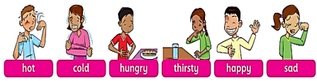 | Good job!  Verbal assessment | PPT
Middle of the lesson  5 min.  5 min. | Teacher Uses Story poster 2 to present the story. Talk about each frame with the class and encourage predictions.  - Ask children to look at the story in their Pupil's Books. Play the recording for them to point to the different speech bubbles.  - Ask comprehension questions, e.g. Are the babies hot/ cold/hungry? Do the babies eat the apples?  - Ask children to look at the story again. They find and point to words from Exercise  - Ask children to look at the photo of the girl at the top of the story. Tell them her name is Marzhan. Read out her speech bubble: I'm happy. Are you happy? Ask children to guess what this means and confirm the meaning with them. Point to a confident child and ask Are you happy? Encourage the child to answer Yes or No. Repeat with a few other children.  Teacher ask students to say “We are happy”  They are happy etc. Ask students to match exercise 3 page 15.  Teacher ask students to work individually and take card from the basket and make sentences  Basket method  Exercise 4 page 15 |  | Pupils have a look at the picturesand guess what the story is about. Then pupils listen to the recording. After that pupils find and point to the words from ex.1. Further pupils drill the phrase Are you happy?  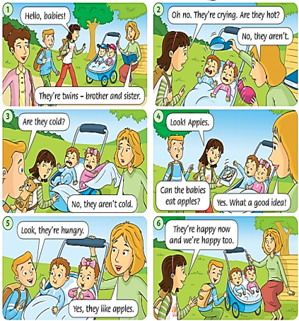 | Descriptor  A learner  - Reads the text  - Answers the questions  Descriptor  A learner  - works individually  - takes one card  - makes sentences | CD 20  https://www.youtube.com/watch?v=Hd7sjF8_Cgs
5 min. | Teacher ask students to work individually and read the sentences then draw a faces  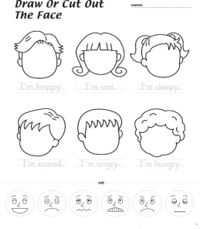 |  | Students work individually and read the sentences then draw a faces | Descriptor  A learner  - Works individually  - Reads sentences  - Draw a faces | Worksheet
5 min. | Teacher ask students to work in groups and find emotions in the word search. Teacher sets a time.  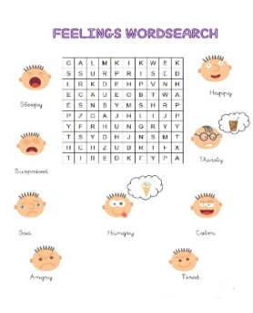 |  | Students work in groups and find new words from the word search. Teacher sets a time. | Descriptor  A learner  - Works in groups  - Searches emotions  Give a sticker for a right answer to encourage pupils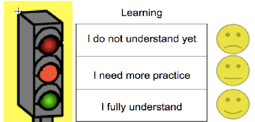 | Worksheet
Physical training exercise  3 min. | A break for physical activity.  Teacher plays the video with physical exercises. |  | Students watch and do physical exercises. | 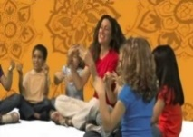 | Music  https://www.youtube.com/watch?v=I5RUzkySseE
4 minұ | Teacher ask students to work in pairs and write emotions in correct place  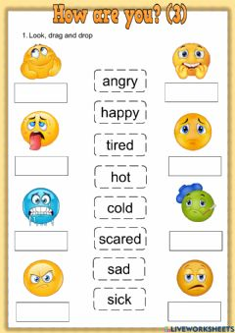 |  | Students work in pairs and write emotions under the smiles | Descriptor  A learner  - Works in pairs  - Writes emotions | Worksheet
5 min. | Teacher ask pupils to play an online game. They should press the start button, and answer the questions  GROUP WORK  SPEAKING |  | Students play online games. They press the start button and answer the questions | 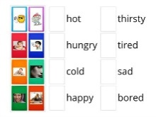 | https://wordwall.net/ru/resource/397601/feelings-and-emotions
The end of the lesson  2 min. | Teacher asks pupils “How are you?” to find out their mood at the end of the lesson, compares it to the initial mood pupils had and makes conclusion how the lesson influenced students and why.  Giving the homework. |  | SS write their homework for the next lesson. | Pupils evaluate themselves using evaluation lists.  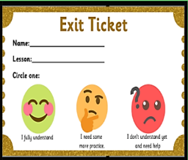 | The end of the lesson

